11th annual  Hebron golf classic  When  Monday April 8th, 2024  8:00 AM Check-In and Breakfast  9:00 AM Shotgun Start  2:00 PM Lunch, Awards & Raffle  Where  The Lakes at Castle Hills  699 Lady of the Lake Boulevard  Lewisville, TX 75056 | 972.899.7400  HEBRON GOLF CONTACT | VP of Fundraising  Jon Booth 214.952.4660  REGISTRATION DEADLINE | 04.01.2024  https://app.eventcaddy.com/events/11th-annual-hebron-golf-classic-89  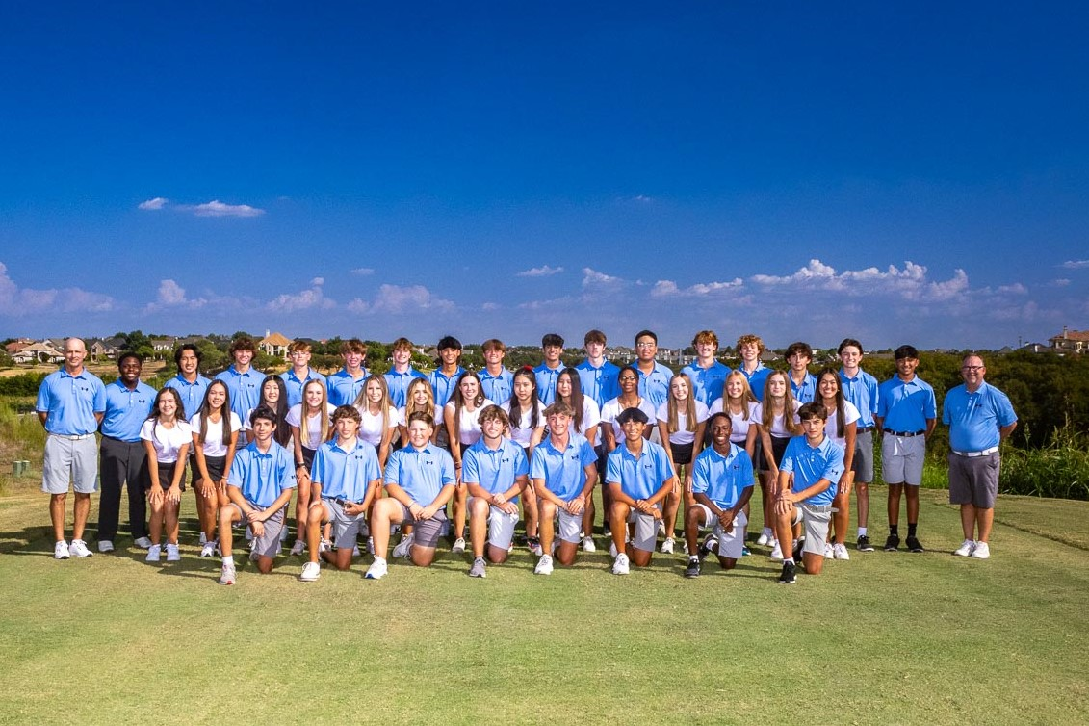 | ADVANCED REGISTRATION  Individual | $175 Per Player  Includes Cart, Range Balls, Goodie Bag, Breakfast, and Lunch  Foursome | $700 Per Team  Includes Cart, Range Balls, Goodie Bag, Breakfast, Lunch, & 1 Mulligan Per Player  Mulligans | $10  AT THE DOOR  Individual | $200 Per Player  Foursome | $750 Per Team  HEBRON HAWK SPONSORS  Sponsor a Hebron Hawk | $200  Hole Sponsor | $250  Logo at Hole, Banner & Website Recognition (Does not include golfer; See Menu, then Store on Registration Landing Page)  Hole Sponsor + Foursome | $900  Entry Fee for 4 players, Cart, Range Balls, 4 Mulligans, Goodie Bag, Breakfast, Lunch, Logo at Hole, Banner & Website Recognition  Bronze Sponsor | $500  Entry Fee for 1 Player, Cart, Range Balls, 1 Mulligan, Goodie Bag, Breakfast, Lunch, Banner & Website Recognition  Silver Sponsor | $1,000  Entry Fee for 2 Players, Cart, Range Balls, 2 Mulligans, Goodie Bag, Breakfast, Lunch, Banner & Website Recognition  Gold Sponsor | $1,500  Entry fee for 4 Players, Cart, Range Balls, 4 Mulligans, Goodie Bag, Lunch, Banner & Website Recognition  Platinum Sponsor | $2,000  Entry Fee for 8 Players, Cart, Range Balls, 8 Mulligans, Goodie Bag, Breakfast, Lunch, Banner & Website Recognition  2024 Title Sponsor | $3,500  Entry Fee for 12 Players, Cart, Range Balls, 12 Mulligans, Goodie Bag, Breakfast, Lunch, Banner & Website Recognition

